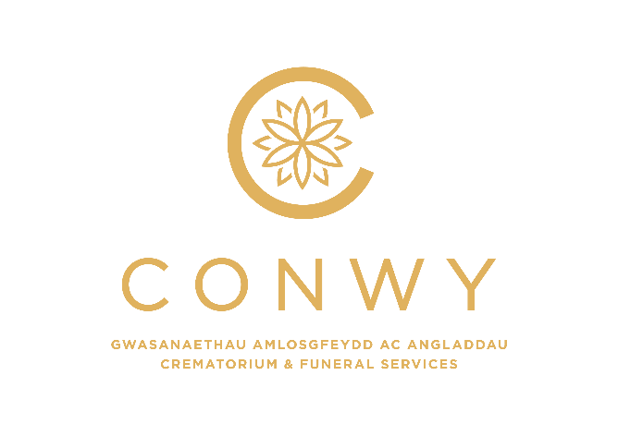

CEMETERIES FEES
Exclusive Rights of Burial
New Grave space: 4’6” deep (1 burial) | £1,303.00
New Grave space: 6’0” deep (2 burials) | £1,546.00
New Grave space: 7’6” deep (3 burials) | £1,785.00
Second interment in 6’0” earth grave | £773.00
Third interment in 7’6” earth grave | £773.00
Second interment in 7’6” earth grave | £886.00
Woodland burial (to include tree) | £1,408.00
Reservation of adjacent woodland grave – deposit of 30% | £423.00
Woodland burial of ashes | £830.00
New Bricked Grave (excluding brickwork):
4’6” deep (1 burial) | £1,533.00
6’0” deep (2 burials) | £1,843.00
7’6” deep (3 burials) | £2,111.00
Reopen Bricked Graves:
2nd burial in 6’0” grave | £1,031.00
3rd burial in 7’6” grave | £1,031.00
2nd burial in 7’6” grave | £1,174.00
Interment of Ashes in existing earth grave | £243.00
Interment of Ashes in new earth grave (½ size) | £788.00
Second Ashes casket at same interment | £113.00
Priority Grave Position – choice | £120.00
Graves for Babies, Infants and children under 18 years | No Charge
(The above graves are for single interment only)
NOTE: Fees are applicable to Conwy residents only, however previous residents who have moved out of the County within the last five years will be charged at the residents’ rate.

Exhumation | £2,056.00
Exhumation of Ashes | £499.00
For interment into same grave | £105.00
Monuments etc. (Permitted over purchased graves only)
Vase or memorial not more than 10” high, and not more than 10” wide, with or without inscription | Included in registration fee
Headstone, cross or vase more than 10” high, and more than 10” wide, with or without inscription | £160.00
Right to place additional inscription on existing memorial | £57.00
Registrar’s Fees
For searching Register of Burials | £25.00
Registration of transfer of grave space | £68.00
Late arrival of paperwork | £35.00

CREMATORIUM FEES
18 years and over | £745.00
Stillborn baby/child under 18 years old | No Charge
Non-viable foetus (NHS) | No Charge
9.00/9.30am Service | £565.00
3.00pm and 3.30pm surcharges in addition to above fee | £150.00
Cemetery Chapel – per 30 min slot | £165.00
Over-run of Chapel Service | £150.00
Direct cremation | £450.00
Interment of ashes in Bronze Plaque site | £110.00
Polytainer for above | £20.00
Scattering of ashes | £40.00
Scattering of ashes from other crematoria | £170.00
Certificate of cremation | £20.00
Wooden Caskets | £60.00
Wicker Caskets | £60.00
Niche caskets (bronze urn) | £42.00
Scattering tubes | £20.00
Storage of ashes after 1 month | £50.00
Music System
Single photo | £10.00
Simple Slideshow (up to 25 pictures) | £60.00
Professional Slideshow (up to 25 pictures) | £85.00
Additional slides (up to 50) | £35.00
DVD / USB | £55.00
CD | £45.00
Webcasting | £60.00

MEMORIALS
Note: Extra Lettering on all memorials is charged at £3.00 per letter plus VAT
Sanctum 2016 + 32 Tower / Above ground vaults including sealing tablet and casket not including Lettering at £ 3.00 per letter plus VAT | £950.00
Sanctum Panorama Tower including granite tablet, polytainer and up to 80 letters | £850.00
Sanctum 12 Unit Vaults including granite tablet, casket and up to 80 letters | £750.00
Copper Posy Holder | £50.00
Wall Niches
Single –including sealing tablet and casket or urn | £350.00
Double –including sealing tablet and casket or urn | £470.00
Lettering (per letter) at £ 3.00 plus VAT
Repaint of Niche single/double | £50.00 plus VAT
Reface of Niche single/double | £50.00 plus VAT
Repaint of existing inscription at same time as new letters | £50.00 plus VAT
Repaint/Reface York Stone Plaque | £170.00
Vase Blocks
With granite tablet including inscription | £470.00
Replacement tablet including inscription | £250.00
Vase Container | £10.00

Octagon Planter including granite tablet and inscription | £354.00
Replacement tablet including inscription | £250.00
Granite Seat Tablets | £327.00
Wall Unit Tablets / Archway Nook
Including granite tablet and Inscription | £420.00
Replacement tablet including inscription | £250.00
Barbican Tower Plaque (10 year lease period) | £420.00
Replacement Tablet | £250.00
Babies and Children’s Memorial - Top Tier - including granite tablet and inscription | £268.00
Babies and Children’s Memorial - Middle Tier - including granite tablet and inscription | £273.00
Mushrooms (Children’s Garden) including granite round tablet and inscription | £220.00
Children’s Picture Book Tablet including lettering (names and dates only) | £320.00
Children Sanctum Tower tablet | £420.00
Lettering £3.00 per letter plus VAT
Curved Seat at Llanrhos with Granite tablet and inscription | £330.00
up to 80 letters for a 10 year period
Replacement Tablet within lease period | £230.00
Motifs and Designs prices start at £80.00 plus VAT dependent upon style and size
Casket (Lettering - £3.00 per letter plus VAT)
Tree and Bronze Plaque | £420.00
Bronze Plaque Only Standard £140.00/Large £240.00
Hardwood Bench and Brass Plaque | £800.00
Tree of Remembrance - Gold Leaf (10 year lease period) | £110.00

Book of Remembrance
Two line entry | £70.00
Additional line (per line) | £35.00
Badge/Flowers/Illustration (NOTE: entry in the book must contain minimum of 5 lines) | £75.00
Miniature Memorial Book
Two line entry | £80.00
Additional lines – per line | £18.00
Badge/Flowers/Illustration | £70.00
Memorial Card
Two line entry | £35.00
Additional lines – per line | £18.00
Badge/Flowers/Illustration | £70.00
Memorial Stained Pane (Cemetery Chapel) | £450.00

